**Zautomate setup in eclipse in Mac machine**

**Requirements:**

* Java 8 0r 7 (please set environment variable)
* Eclipse (Luna, Mars or any)
* Maven, TestNG plugins ( install Eclipse Marketplace)
* GitHub Desktop for windows
* Maven jar in local ( to create executable jar )

**Configuration:**

1. To download ‘qa-automation’ package from GitHub, install GitHub desktop on your windows machine
2. Hey there, we’re just writing to let you know that you’ve been automatically subscribed to a repository on GitHub.

ZillionGroup/qa-automation

QA automated testing tool

<https://github.com/ZillionGroup/qa-automation>

1. Select directory as C:/ workspace

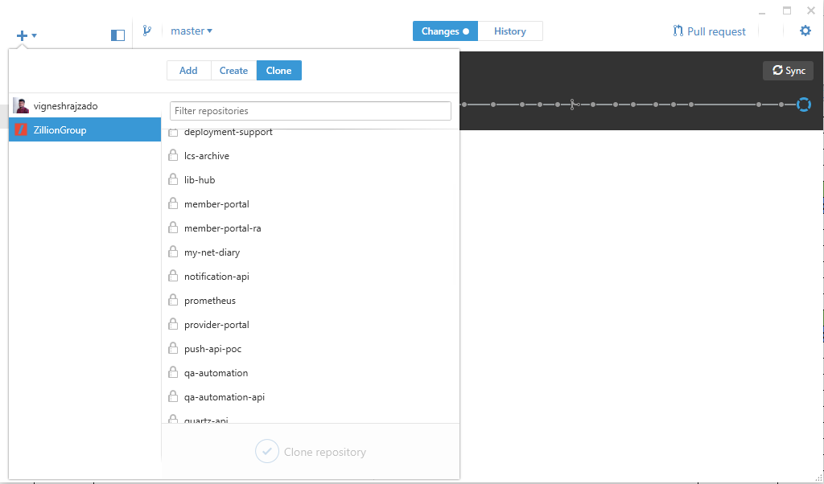

1. Select ‘qa-automation’ and Clone the repository. Entire project will be cloned under local windows machine.
2. Now File -> Import… -> Existing Maven Project -> Browser and locate ‘zillionqa’
3. 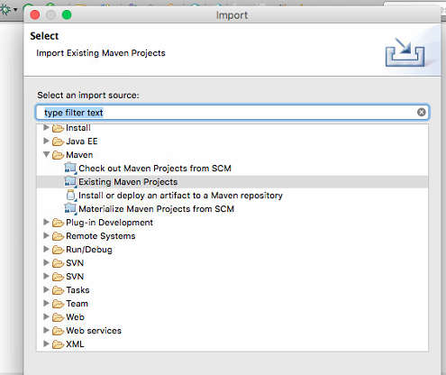
4. Current path in Mac machine: /Users/hfqateam/Documents/workspace/qa-automation/zillionqa
5. Setup all your property files and test cases in your desired location (Eg: /Users/hfqateam/Documents/workspace/qa-automation/Zillion/testcases)

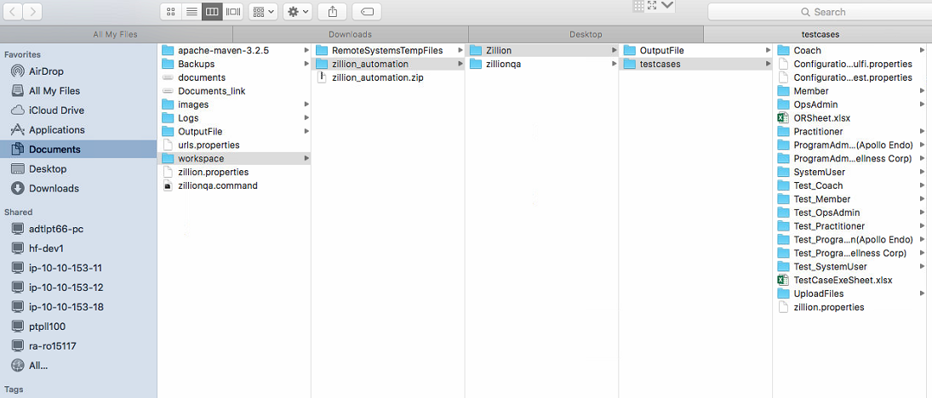

1. If you want to execute from eclipse -> Just run as ProgramTestNG class as java application.
2. Please check arguments in Run Configuration

-Dzado.reporter.config=/Users/hfqateam/Documents/workspace/qa-automation/Zillion/testcases/zillion.properties -DlogfileLoc=/Users/hfqateam/Documents\Logs -Dzado.execution.parseq=sequential

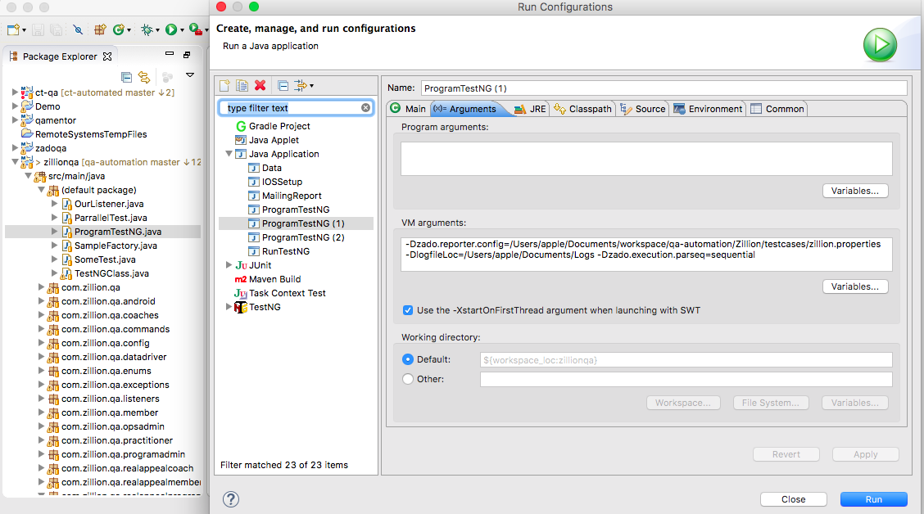

1. Then Run
2. It will execute the suite based on your configuration.
3. If you want to execute without eclipse. You have to install maven jar (need to set environment variable) in your machine and create an executable jar to framework.
4. Open terminal -> Then navigate upto “/Users/hfqateam/Documents/workspace/qa-automation/zillionqa”
5. Then use “mvn install package” -> Enter
6. It will create that executable jar in “Users/hfqateam/Documents/workspace/qa-automation/zillionqa/target” location as “zillionqa-jar-with-dependencies.jar”.
7. Create/copy a file for command line execution. Just edit and change the property file path inside the command file. Find the attachment



1. Then double click this command line and it will execute the suite as well.
2. i. To update the latest committed scripts from others and test cases:

Open GitHub desktop and click ‘sync’

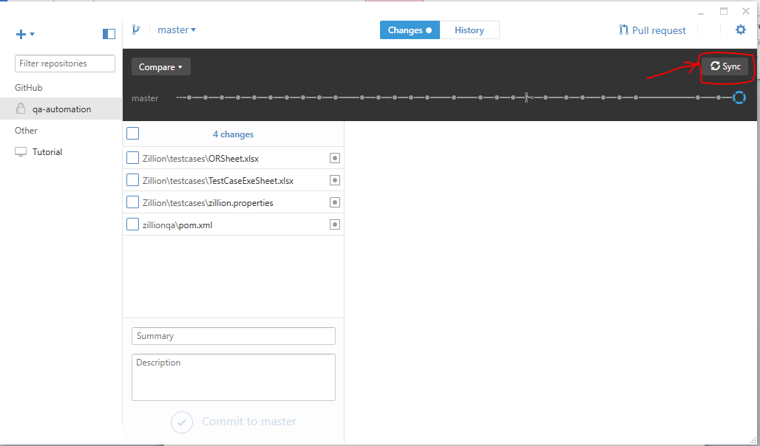

1. To commit the latest modified scripts select the checkboxes that needs to be committed. Type the summary for the modification and click ‘Commit to master’. Finally ‘Sync’ once you commit the scripts.

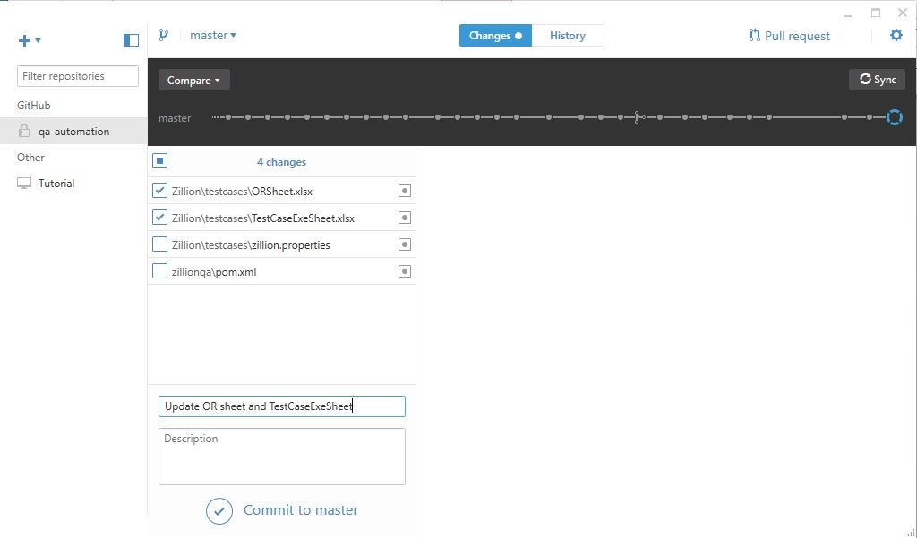

Note:

Before execution need to configure TestcaseExeSheet.

